2021 Spring CM390 C# – Semester Project-Xuan Lu

This project is designed for business delivery.

Business can input new customer information to the DataGrid View by click Save button.

New button will clean out text box and ready for next input.

Update button is only saving the changed message and update in the DataGrid View.

They can use Search to check if the customer information in the file or not. Also, can use Sort to organized customer information file by alphabetical order.

This project basically is insert, update, delete, search, and sort data in DataGrid view, without using database. Also export data from DataGrid view to .txt file.

The StreamWriter Path in frmCustomerInf #152 line

The Customer information form

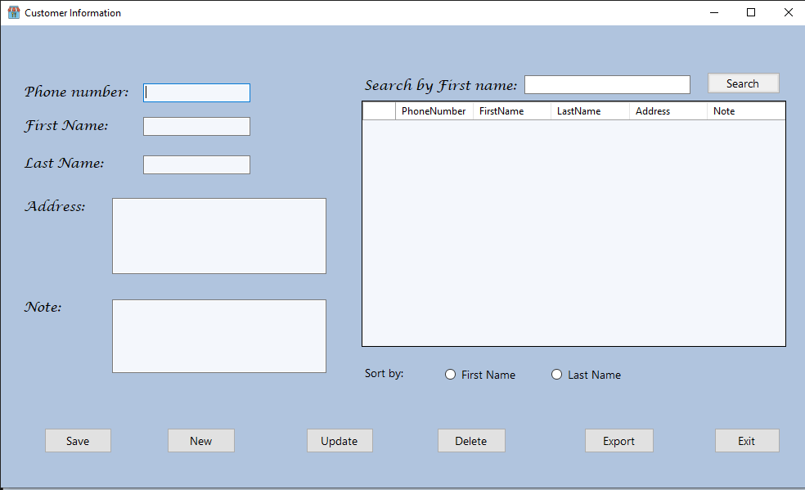

The delete form.

